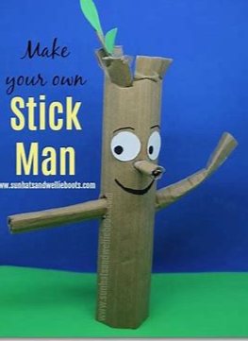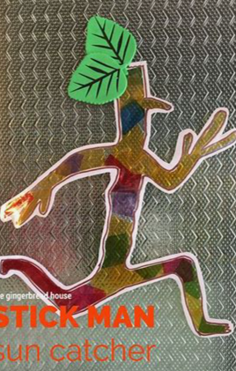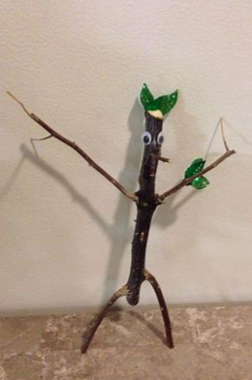

Our next unit in Literacy will be all about Stick Man. Can you create your own Stick Man? You could use lots of different things to create your Stick Man including:

* Sticks
* Toilet roll tubes
* Pipe cleaners
* Paint
* Pens
* Cardboard

If you manage to make a Stick Man, bring him in for us all to see (or send in a photo)!